Installing the MISA Transformation Plugins

Installing
You should have a zip file, such as ‘misa update site.zip’.
- Within RSA/RSM, select “Help > Software Updates…”
- If you have previously followed these steps and have put the new installation file to the exact same location (and filename) as the previous one, then you can skip these sub-steps.
  - Click on ‘Add Site…’
  - Press the ‘Archive...’ button.
  - Navigate to and select the installation zip file and then press Open.
  - Then press OK
- In the list of Available Software, you should see the installation file. You should be able to expand it and see ‘MISA Transformations’.
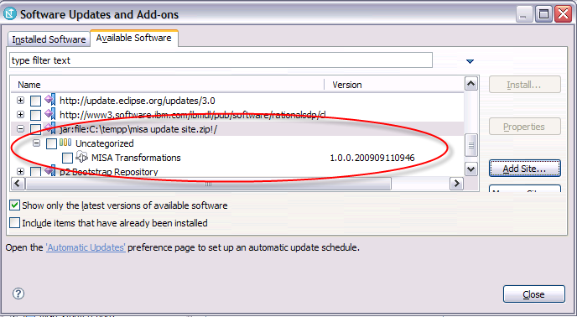
- Select the checkbox next to ‘MISA Transformations’ and then click on “Install…”
- Press the Next button
- Accept the license terms and press the Finish button
- Restart RSA/RSM when prompted.

